**1) Click the “Backdrops” tab**

**2) Use the Fill tool to color the background green**

**3) Use the circle tool to create a track**

**4) Use the line tool to draw a white finish line**

**5) Switch to the text tool**

**6) Create a blue ‘ V ’, resize it and place it on the track**

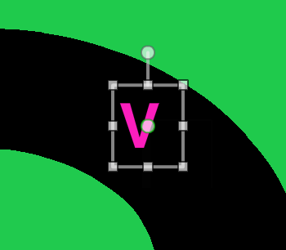

**7) Click the “Open” button on the left window pane**

**8) Open the Sprite of your choice in the file explorer**

**9) Events -> When [Flag] Clicked**

**10) Looks -> Switch costume to [costume1]**

**11) Motion ->** Go to x/y coordinates / **Motion ->** Point in direction 90 (right)

**12) Events -> When [Flag] Clicked**

**13) Looks ->** Say [] for 1 second (drag three times)

**14) Control ->** Forever

**15) Motion ->** Move 2 steps

**16) Sensing ->** Touching color (green) -> click the “color” box then click the background

**17) Control ->** If / then

**18) Looks ->** Switch costume to [costume2]

**19) Control ->** Stop all

**20) Control ->** If / then

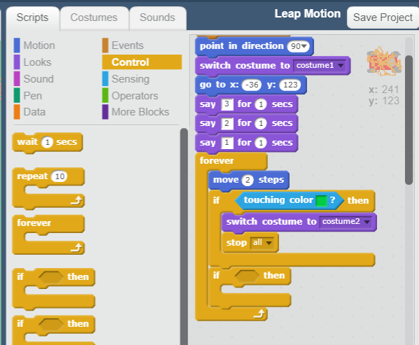

**21) Sensing ->** Touching color (white) -> click the “color” box then click the white line

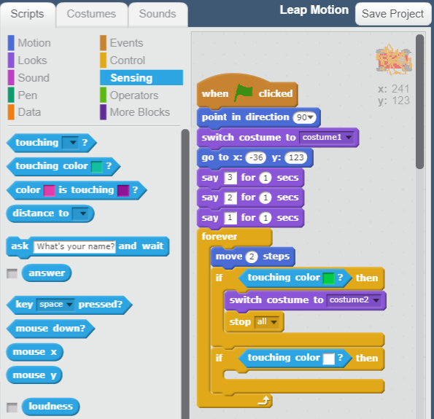

**22) Looks ->** Say “You won!” for 2 seconds

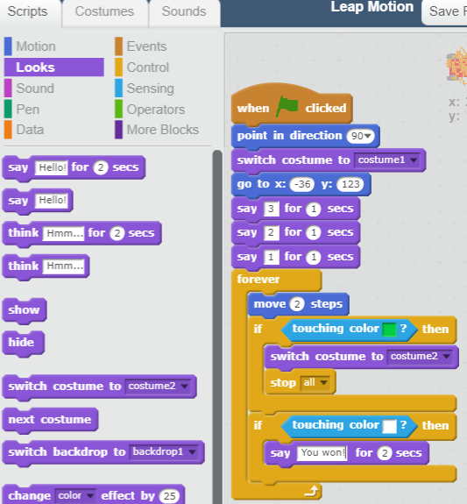

**23) Control ->** Stop all

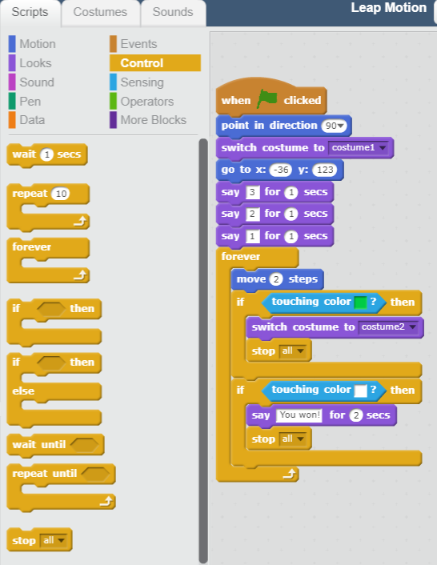

**24) Control ->** If / then

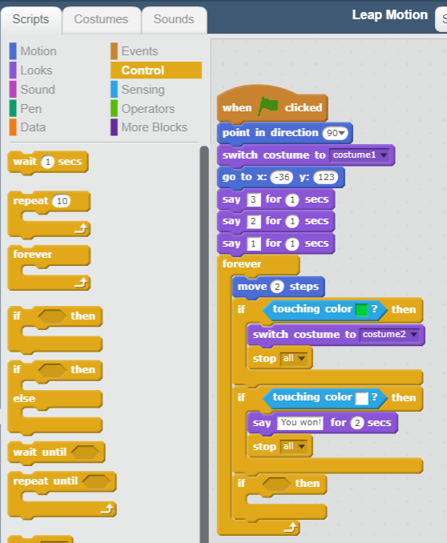

**25) Sensing ->** Touching color (pink) -> click the “color” box then click the boost “V”

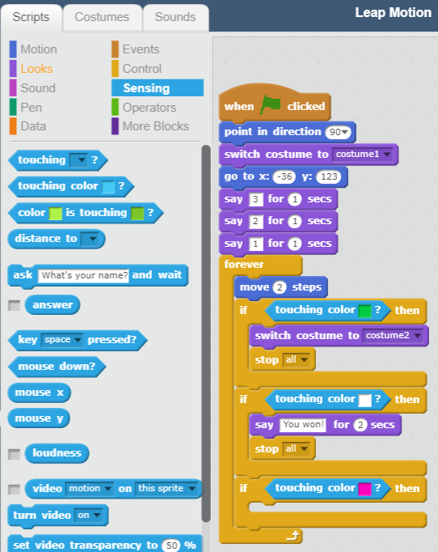

**26) Motion ->** Move 5 steps

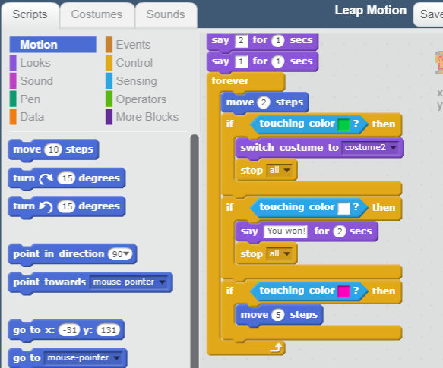

**27) Events ->** When (right arrow) key pressed

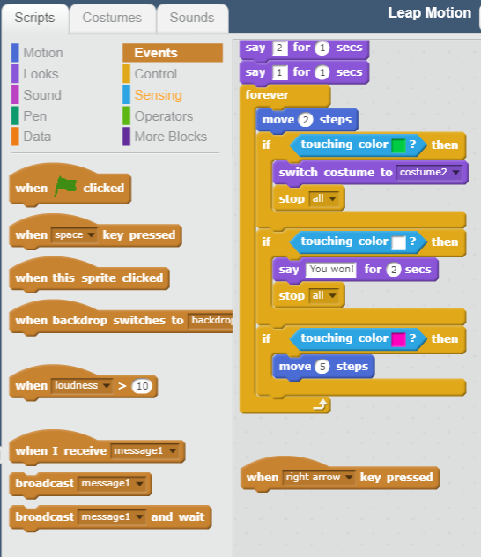

**28) Motion ->** Turn (right 15 degrees)

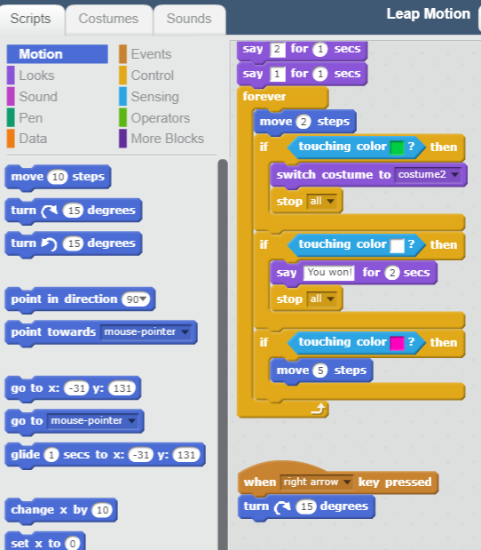

**29) Events ->** When (left arrow) key pressed

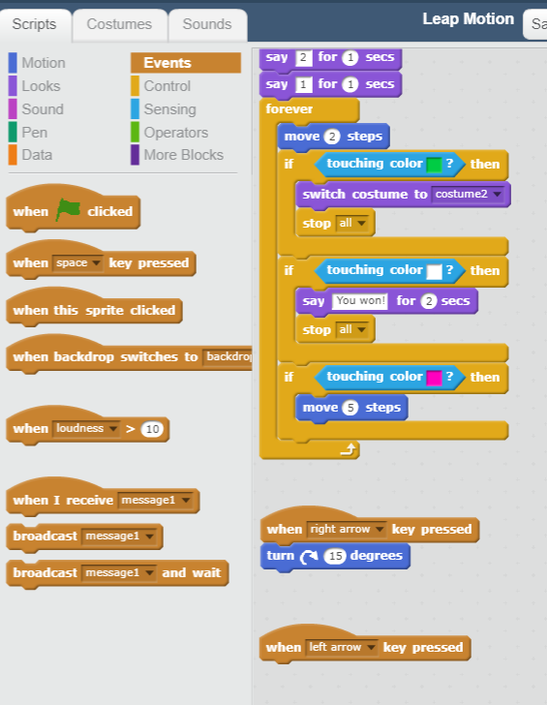

**30) Motion ->** Turn (left 15 degrees)

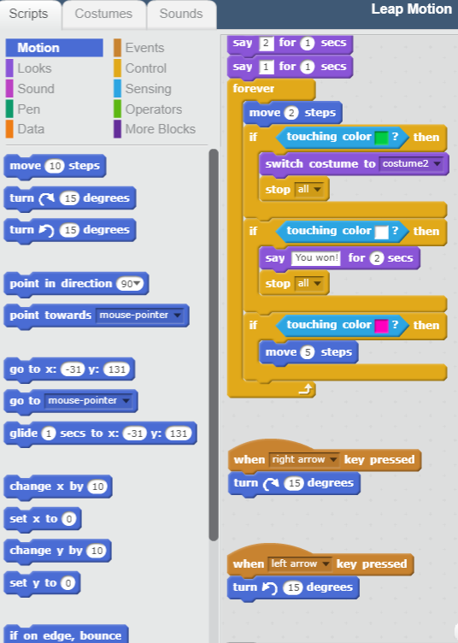

**Summary**

**Steps 9-11: What happens when you start the game?**

Set the car’s X / Y start coordinates, the direction that car is facing, and the non-crashed car

**Steps 14-15: What about moving forward?**

The “forever” block will continue moving the car forward indefinitely

**Steps 16-19: What about crashing? How do they know they’ve crashed?**

The “if” statement will stop the car from moving and change it to a crashed car when it touches the “green” color

**Steps 20-23: What about winning? What signals that you’ve won the game?**

If the car touches the white line, you’ve won. Display a winning message and stop the game.

**Steps 24-26: What about “boost”? How do we make the car go faster?**

If the car touches the pink “V” we want it to go faster. Instead of moving just 2 steps, we want to move 5 steps.

**Steps 27-30: How do we steer the car?**

The “listeners” watch for the left / right keyboard arrows and then turn the car 15 degrees. You can change the “15 degrees” value to make the car turn more / less. Try it!